**Intermediate Algebra Unit 7 Part 1 Review**

Name: _____________________________________________ Period: _________

**Problems 1 – 2: Graph the following radical functions using a table of points, then find domain and range.**

**1. $f\left(x\right)=-2∙\sqrt[3]{x+2}+4$**



|  |  |
| --- | --- |
| ***x*** | ***y*** |
|  |  |
|  |  |
|  |  |
|  |  |
|  |  |
|  |  |
|  |  |

Inflection Pt:

Domain: ___________

Range: ____________

**2. $f\left(x\right)=\sqrt{x-1}-4$**



|  |  |
| --- | --- |
| ***x*** | ***y*** |
|  |  |
|  |  |
|  |  |
|  |  |
|  |  |
|  |  |
|  |  |

Starting Pt:

Domain: ___________

Range: ____________

**3.** Write the equation of the following graphed function. Write the domain and range.

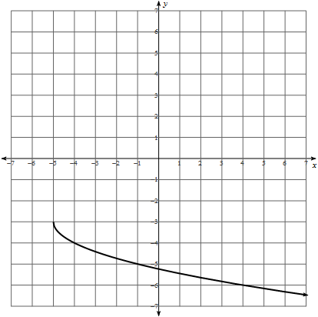

Starting Pt:

*f*(*x*) = __________________

Domain: ________________

Range: ________________

**4.** The amount of money you earn per hour at a math text book company depends on how many pages you correct. This situation follows a square root function $M\left(p\right)=2∙\sqrt{p+2}+3$. Answer the following questions from the graph below

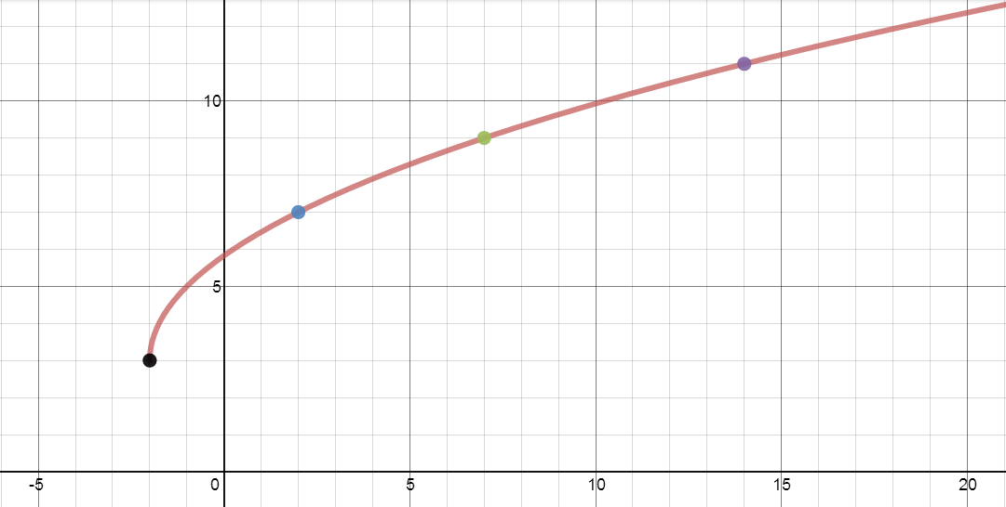

1. Name the *y*-intercept. What does it mean in terms of this problem?
2. Name the *x*-intercept. What does it mean in terms of this problem?

Simplify the expression.

**5**.  **6**.  **7**. 

Ans: _________ Ans: _________ Ans: _________

**8.**  **9**.  **10**. 

Ans: _________ Ans: _________ Ans: _________

**Rewrite in rational exponent form.**

**11**.  **12**.  **13**. 

Rewrite:____________ Rewrite:____________ Rewrite:___________

**Rewrite in radical form.**

**14.**   **15.**  **16.**  

Rewrite:____________ Rewrite:____________ Rewrite:____________

**Simplify the expressions using properties of rational exponents.**

**17.  18.**  **19.**  **20.** 

Ans: _________ Ans: _________ Ans: _________ Ans: _________

**Simplify the expressions using properties of radical expressions. Use absolute value when necessary.**

**21.  22.  23.  24.** 

Ans: _________ Ans: _________ Ans: _________ Ans: _________